**Chapter 12 Reports**

This section allows you to view and print up-to-date reports based on your selected criteria.

*In This Chapter :*

*12.1 Account Reports – Clients’ Account*

*12.1.1 Client Ledger*

*12.1.2 File Advanced Payment*

*12.1.3 Fund Transfer Between Bank List*

*12.1.4 Fund Transfer Between File List Report*

*12.1.5 Trial Balance for Clients’ Account*

*12.2 Account Reports – Office Account*

*12.2.1 Balance Sheet*

*12.2.1 Chart of Accounts*

*12.2.1 G/L Listing*

*12.2.1 Unpresented Cheque List*

*12.2.1 Clients’ Account Journal List*

*12.2.1 Office Account Journal List*

*12.2.1 Profit and Loss*

*12.2.1 Profit and Loss (By Month)*

*12.2.1 Profit and Loss (Year Comparison)*

*12.2.1 Trial Balance for Office Account*

*12.2.1 Trial Balance for Office Account (By Month)*

*12.2.1 Trial Balance for Office Account (By Year)*

*12.3 Account Reports – Payment Voucher*

*12.3.1 A/P Payment List*

*12.3.1 Client’s A/C Payment Voucher List*

*12.3.1 Office A/C Payment Voucher List*

*12.4 Account Reports – Receipt / AR Receipt*

*12.4.1 A/R Receipt List*

*12.4.1 Contra Bill List*

*12.4.1 Receipt List*

*12.4.1 Activity (A/R Trans.)*

*12.5 Account Reports – Sales / Quotation*

*12.5.1 A/R CN List*

*12.5.1 A/R DN List*

*12.5.1 Account Statement*

*12.5.1 Bill Listing*

*12.5.1 Bill Payment Report*

*12.5.1 Time Cost Listing*

*12.5.1 Past Bill List*

*12.5.1 Quotation Listing*

*12.6 Account Reports – Supplier*

*12.6.1 A/P CN List*

*12.6.1 A/P DN List*

*12.6.1 Invoice Aging Report*

*12.6.1 Supplier Invoice List*

*12.6.1 Supplier Listing*

*12.7 Account Reports – Tax*

*12.7.1 GST Form 03*

*12.7.2 GST Transaction List*

*12.7.3 SST 02 Form*

*12.7.4 SST Transaction List*

*12.8 General Report*

*12.8.1 Activity Listing*

*12.8.1 Client Listing*

*12.8.1 Client Mailing Label*

*12.8.1 File Detail SpreadSheet*

*12.8.1 File Listing*

*12.8.1 File Summary*

*12.9 Task / Workflow Report*

*12.9.1 Appointment List*

*12.9.1 Court Matter List*

*12.9.1 Task To Do List*

*12.10 Manage Reports*

**12.1 Account Reports – Clients’ Account**

**12.1.1 Client Ledger**

This enables you to view and print client ledger report. This ledger provides GL transaction listing for the client.

* On the ‘**Report**’ Menu, click ‘**Account Reports – Clients’ Account**’.
* Click ‘**Client Ledger**’ and a window will pop-up as the picture below.

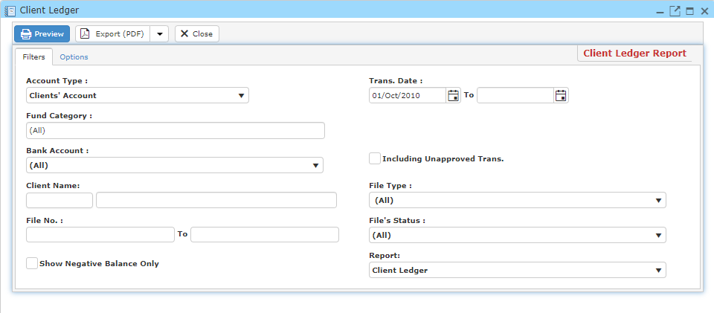

* To begin, choose an account type and fill in your criteria.
* If you wish to add watermark to your report, Click ‘**Options**’ and fill in the necessary information.

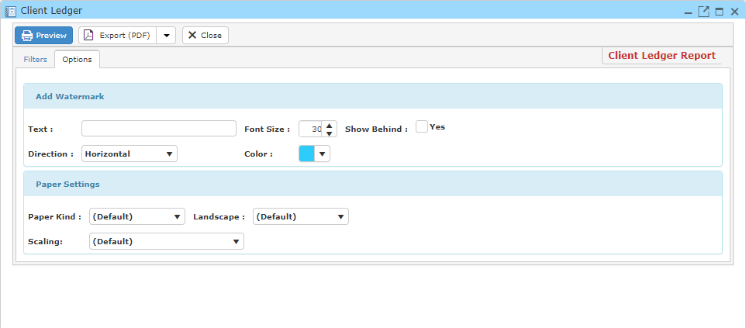

* Click ‘**Preview**’ to view and print out the client ledger report.
* You may also export this report in PDF or Excel format by clicking the ‘**Export**’ button.

**12.1.2 File Advanced Payment**

This enables you to view and print file advanced payment report.

* On the ‘**Report**’ Menu, click ‘**Account Reports – Clients’ Account**’.
* Click ‘**File Advanced Payment Report**’ and a window will pop-up as the picture below.

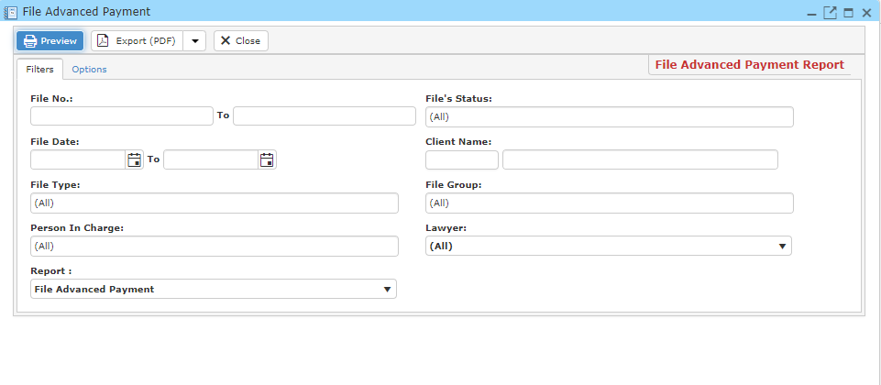

* Fill in your search criteria.
* If you wish to add watermark to your report, Click ‘**Options**’ and fill in the necessary information.

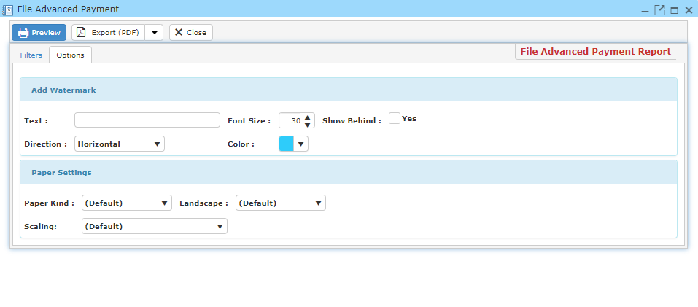

* Click ‘**Preview**’ to view and print out the file advanced payment report.
* You may also export this report in PDF or Excel format by clicking the ‘**Export**’ button.

**12.1.3 Fund Transfer Between Bank List**

This enables you to view and print fund transfer between bank list report.

* On the ‘**Report**’ Menu, click ‘**Account Reports – Clients’ Account**’.
* Click ‘**Client Ledger**’ and a window will pop-up as the picture below.

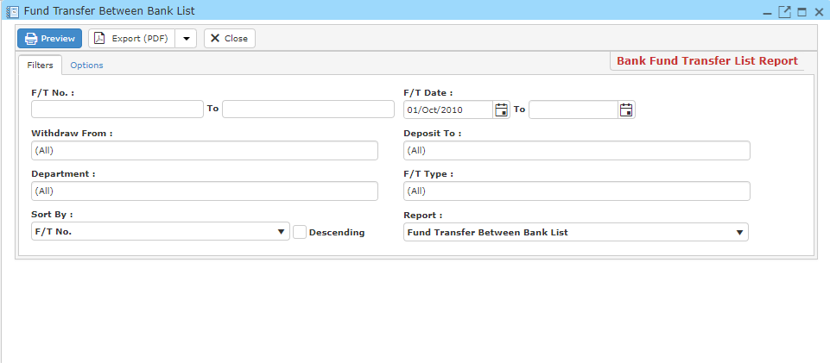

* Fill in your search criteria.
* If you wish to add watermark to your report, Click ‘**Options**’ and fill in the necessary information.

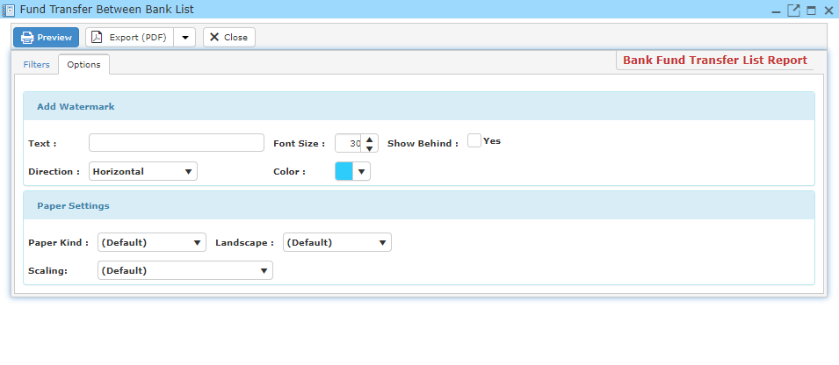

* Click ‘**Preview**’ to view and print out the funds transfer between bank list report.
* You may also export this report in PDF or Excel format by clicking the ‘**Export**’ button.

**12.1.4 Fund Transfer Between File List Report**

This enables you to view and print fund transfer between file list report.

* On the ‘**Report**’ Menu, click ‘**Account Reports – Clients’ Account**’.
* Click ‘**Client Ledger**’ and a window will pop-up as the picture below.

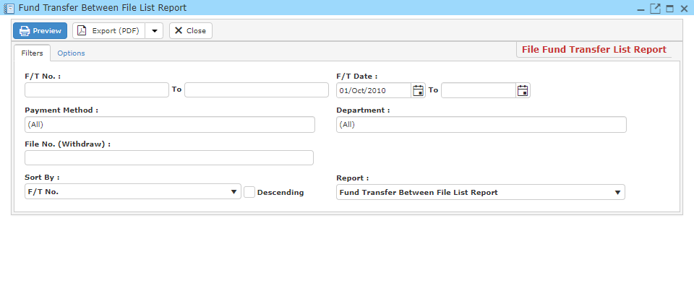

* Fill in your search criteria.
* If you wish to add watermark to your report, Click ‘**Options**’ and fill in the necessary information.

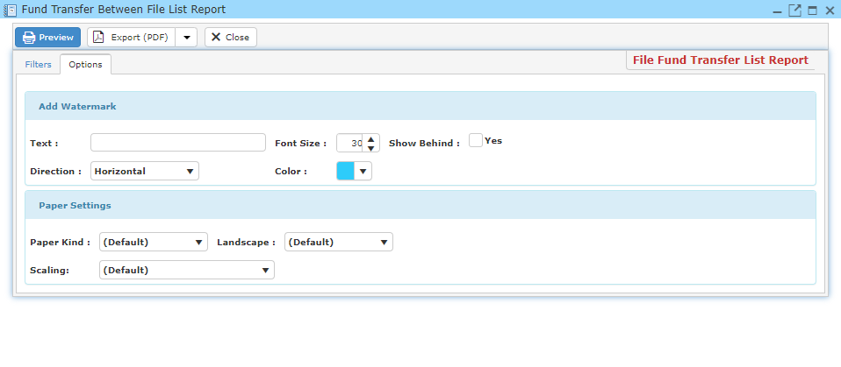

* Click ‘**Preview**’ to view and print out the fund transfer between file list report.
* You may also export this report in PDF or Excel format by clicking the ‘**Export**’ button.

**12.1.5 Trial Balance for Clients’ Account**

This enables you to view and print trial balance for clients’ account report.

* On the ‘**Report**’ Menu, click ‘**Account Reports – Clients’ Account**’.
* Click ‘**Client Ledger**’ and a window will pop-up as the picture below.

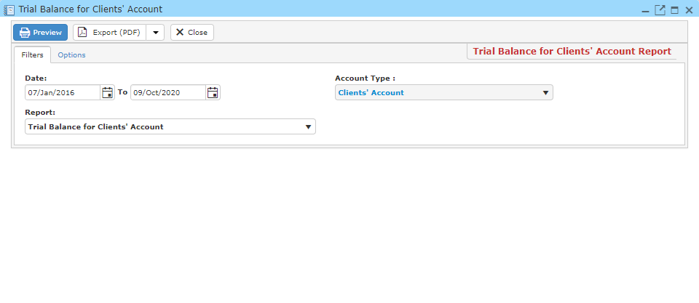

* Fill in your search criteria.
* If you wish to add watermark to your report, Click ‘**Options**’ and fill in the necessary information.

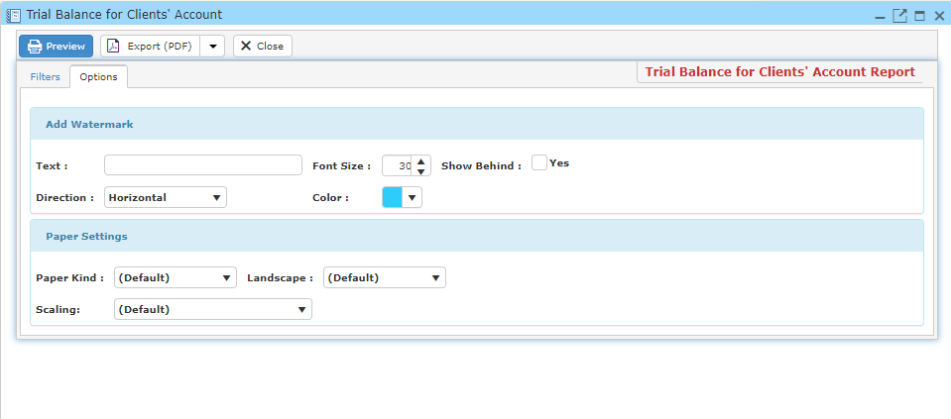

* Click ‘**Preview**’ to view and print out the trial balance for clients’ account report.
* You may also export this report in PDF or Excel format by clicking the ‘**Export**’ button.

**12.2 Account Reports – Office Account**

**12.2.1 Balance Sheet**

This enables you to view and print trial balance for clients’ account report.

* On the ‘**Report**’ Menu, click ‘**Account Reports – Clients’ Account**’.
* Click ‘**Client Ledger**’ and a window will pop-up as the picture below.

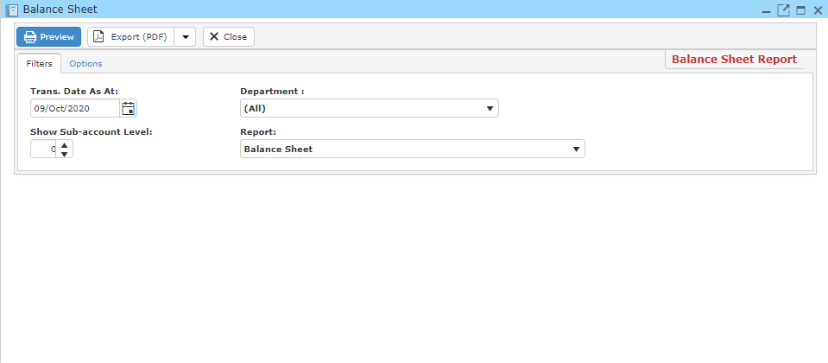

* Fill in your search criteria.
* If you wish to add watermark to your report, Click ‘**Options**’ and fill in the necessary information.
* Click ‘**Preview**’ to view and print out the trial balance for clients’ account report.
* You may also export this report in PDF or Excel format by clicking the ‘**Export**’ button.

**12.2.2 Chart of Accounts**

This enables you to view and print Chart of Accounts report.

* On the ‘**Report**’ Menu, click ‘**Account Reports – Office’s Account**’.
* Click ‘**Chart of Accounts**’ and a window will pop-up as the picture below.

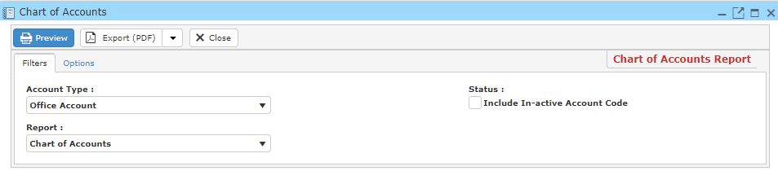

* Fill in your search criteria.
* If you wish to add watermark to your report, Click ‘**Options**’ and fill in the necessary information.

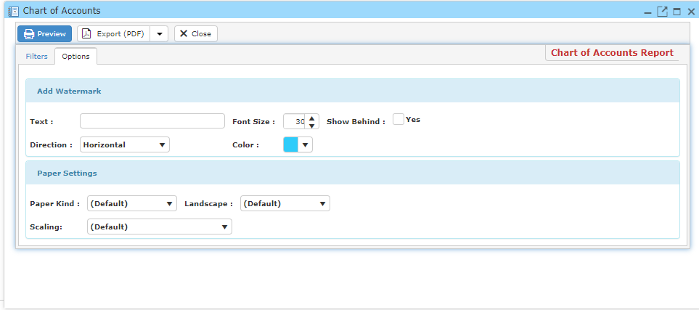

* Click ‘**Preview**’ to view and print out the Chart of Account report.
* You may also export this report in PDF or Excel format by clicking the ‘**Export**’ button.

**12.2.3 G/L Listing**

This enables you to view and print G/L Listing report.

* On the ‘**Report**’ Menu, click ‘**Account Reports – Office’s Account**’.
* Click ‘**G/L Listing**’ and a window will pop-up as the picture below.

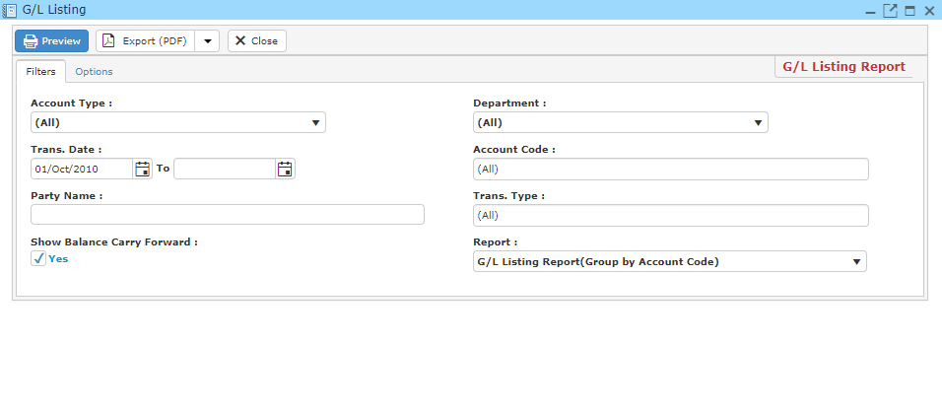

* Fill in your search criteria.
* If you wish to add watermark to your report, Click ‘**Options**’ and fill in the necessary information.

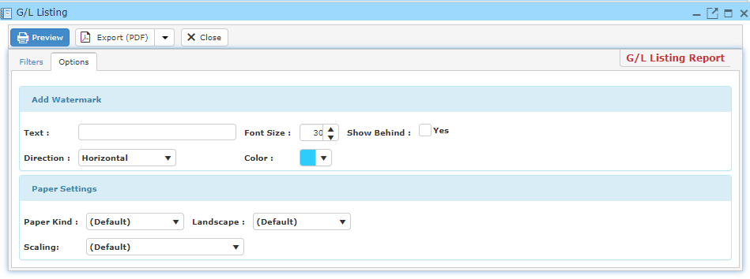

* Click ‘**Preview**’ to view and print out the G/L Listing report.
* You may also export this report in PDF or Excel format by clicking the ‘**Export**’ button.

**12.2.4 Unpresented Cheque List**

This enables you to view and print Unpresented Cheque List report.

* On the ‘**Report**’ Menu, click ‘**Account Reports – Office’s Account**’.
* Click ‘**Unpresented Cheque List**’ and a window will pop-up as the picture below.

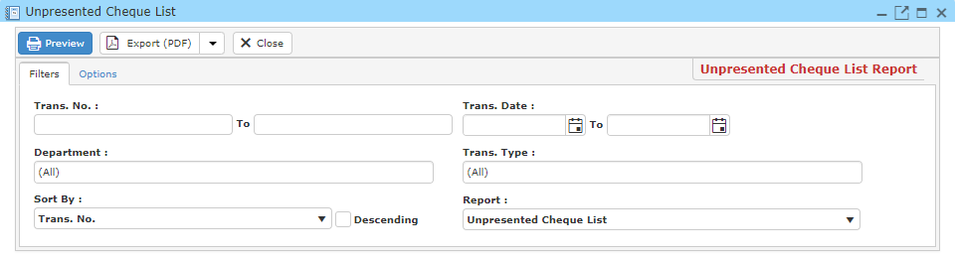

* Fill in your search criteria.
* If you wish to add watermark to your report, Click ‘**Options**’ and fill in the necessary information.

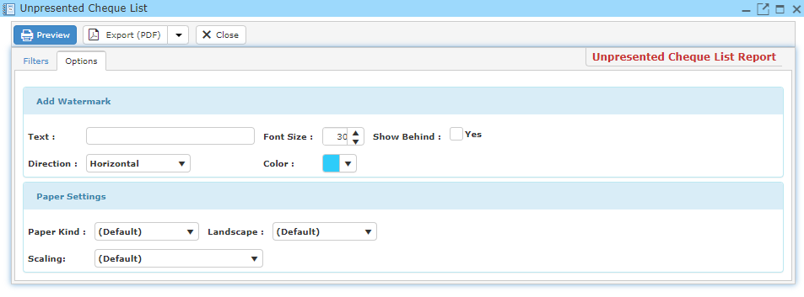

* Click ‘**Preview**’ to view and print out the Unpresented Cheque List report.
* You may also export this report in PDF or Excel format by clicking the ‘**Export**’ button.

**12.2.5 Clients’ Account Journal List**

This enables you to view and print Clients’ Account Journal List report.

* On the ‘**Report**’ Menu, click ‘**Account Reports – Office’s Account**’.
* Click **‘Clients’ Account Journal List’** and a window will pop-up as the picture below.

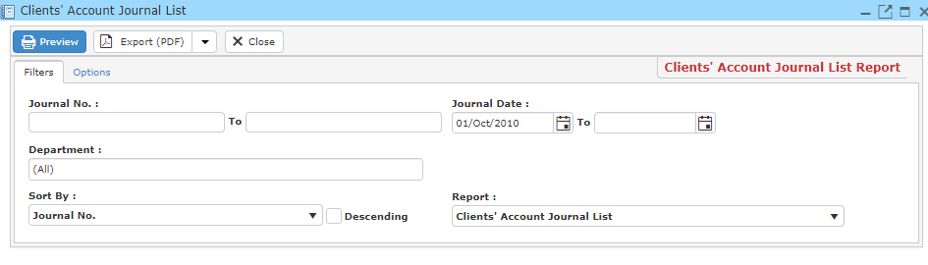

* Fill in your search criteria.
* If you wish to add watermark to your report, Click ‘**Options**’ and fill in the necessary information.

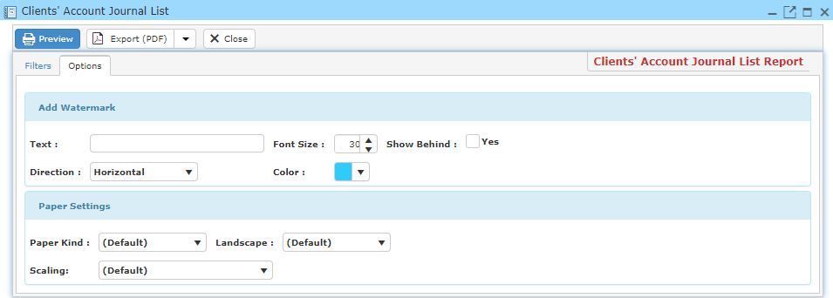

* Click ‘**Preview**’ to view and print out the Clients’ Account Journal List report.
* You may also export this report in PDF or Excel format by clicking the ‘**Export**’ button.

**12.2.6 Office Account Journal List**

This enables you to view and print Office Account Journal List report.

* On the ‘**Report**’ Menu, click ‘**Account Reports – Office’s Account**’.
* Click ‘**Office Account Journal List**’ and a window will pop-up as the picture below.

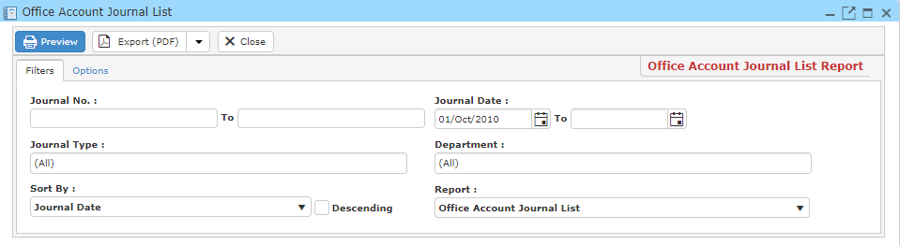

* Fill in your search criteria.
* If you wish to add watermark to your report, Click ‘**Options**’ and fill in the necessary information.

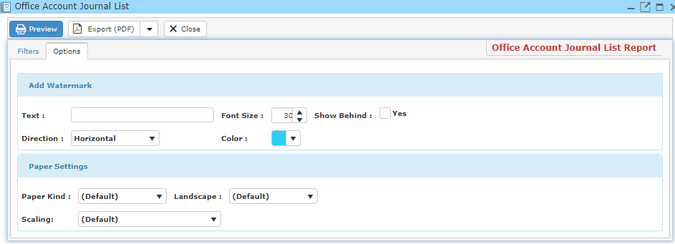

* Click ‘**Preview**’ to view and print out the Office Account Journal List report.
* You may also export this report in PDF or Excel format by clicking the ‘**Export**’ button.

**12.2.7 Profit and Loss**

This enables you to view and print Profit and Loss report.

* On the ‘**Report**’ Menu, click ‘**Account Reports – Office’s Account**’.
* Click ‘**Profit and Loss’**and a window will pop-up as the picture below.

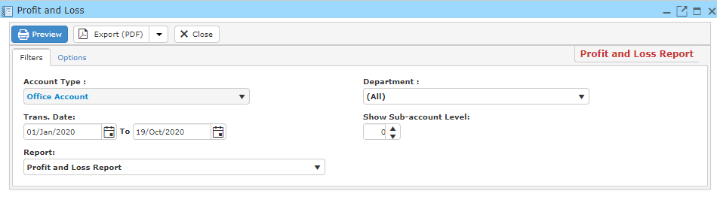

* Fill in your search criteria.
* If you wish to add watermark to your report, Click ‘**Options**’ and fill in the necessary information.

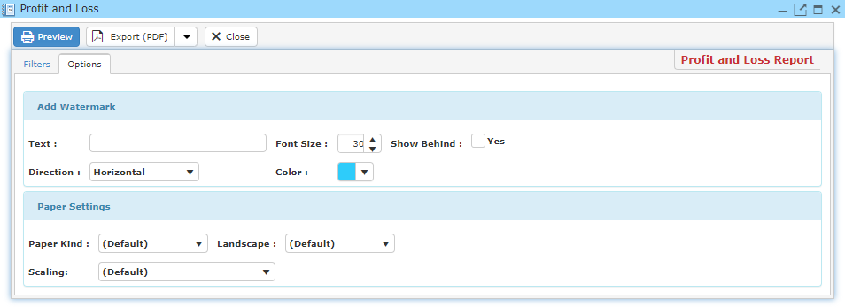

* Click ‘**Preview**’ to view and print out the Profit and Loss report.
* You may also export this report in PDF or Excel format by clicking the ‘**Export**’ button.

**12.2.8 Profit and Loss (By Month)**

This enables you to view and print Profit and Loss (By Month) report.

* On the ‘**Report**’ Menu, click ‘**Account Reports – Office’s Account**’.
* Click ‘**Profit and Loss (By Month)**’ and a window will pop-up as the picture below.

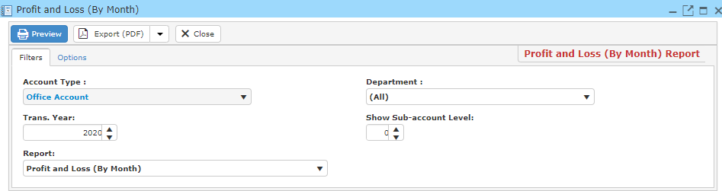

* Fill in your search criteria.
* If you wish to add watermark to your report, Click ‘**Options**’ and fill in the necessary information.

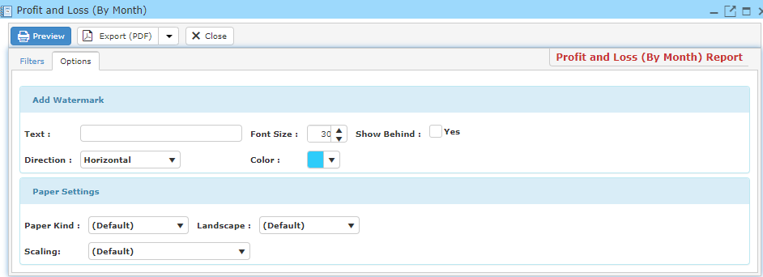

* Click ‘**Preview**’ to view and print out the Profit and Loss (By Month) report.
* You may also export this report in PDF or Excel format by clicking the ‘**Export**’ button.

**12.2.9 Profit and Loss (Year Comparison)**

This enables you to view and print Profit and Loss (Year Comparison) report.

* On the ‘**Report**’ Menu, click ‘**Account Reports – Office’s Account**’.
* Click ‘**Profit and Loss (Year Comparison)**’ and a window will pop-up as the picture below.

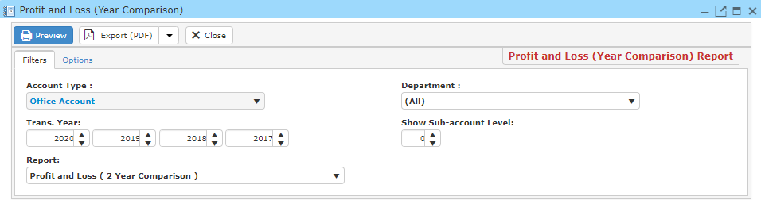

* Fill in your search criteria.
* If you wish to add watermark to your report, Click ‘**Options**’ and fill in the necessary information.

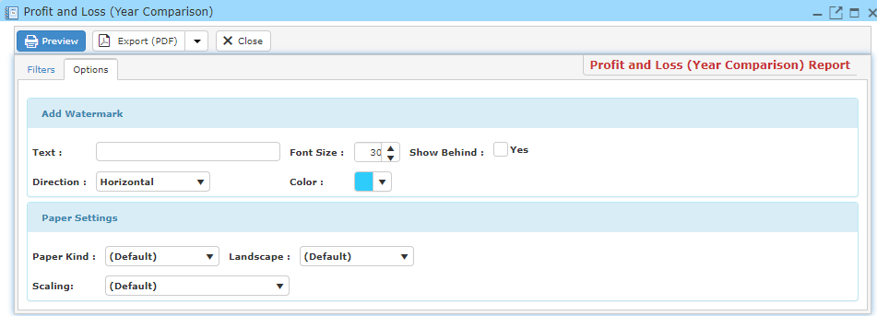

* Click ‘**Preview**’ to view and print out the Profit and Loss (Year Comparison) report.
* You may also export this report in PDF or Excel format by clicking the ‘**Export**’ button.

**12.2.10 Trial Balance for Office Account**

This enables you to view and print Trial Balance for Office Account report.

* On the ‘**Report**’ Menu, click ‘**Account Reports – Clients’ Account**’.
* Click ‘**Trial Balance for Office Account**’ and a window will pop-up as the picture below.

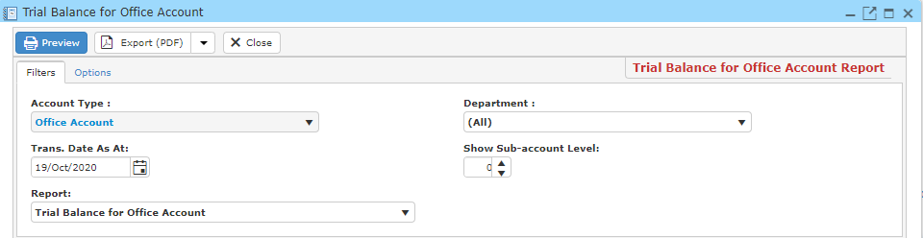

* Fill in your search criteria.
* If you wish to add watermark to your report, Click ‘**Options**’ and fill in the necessary information.

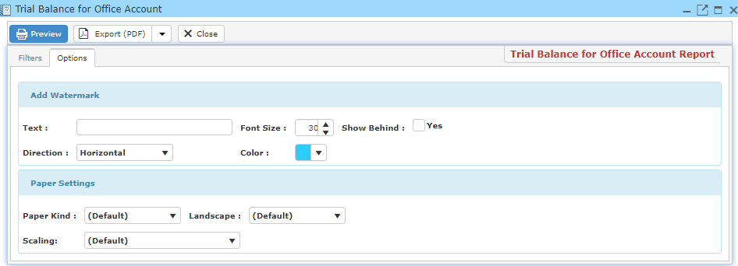

* Click ‘**Preview**’ to view and print out the Trial Balance for Office Account report.
* You may also export this report in PDF or Excel format by clicking the ‘**Export**’ button.

**12.2.11 Trial Balance for Office Account (By Month)**

This enables you to view and print Trial Balance for Office Account (By Month) report.

* On the ‘**Report**’ Menu, click ‘**Account Reports – Clients’ Account**’.
* Click ‘**Trial Balance for Office Account (By Month)**’ and a window will pop-up as the picture below.

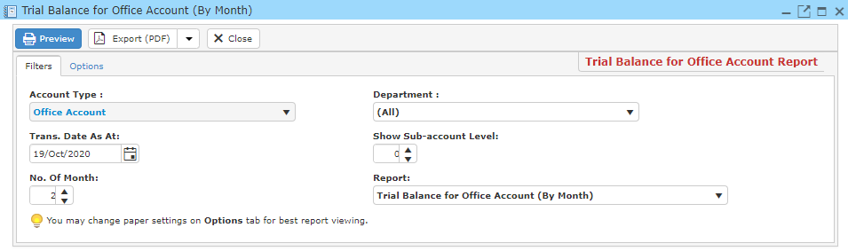

* Fill in your search criteria.
* If you wish to add watermark to your report, Click ‘**Options**’ and fill in the necessary information.

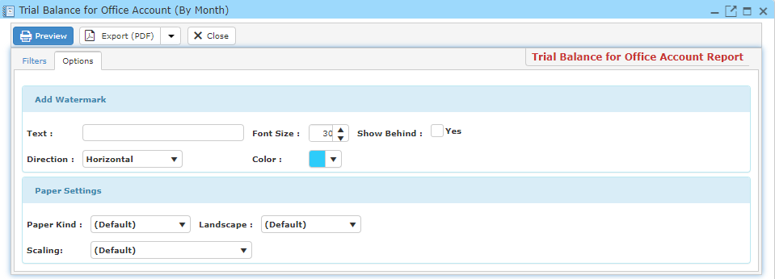

* Click ‘**Preview**’ to view and print out the Trial Balance for Office Account (By Month) report.
* You may also export this report in PDF or Excel format by clicking the ‘**Export**’ button.

**12.2.12 Trial Balance for Office Account (By Year)**

This enables you to view and print Trial Balance for Office Account (By Year) report.

* On the ‘**Report**’ Menu, click ‘**Account Reports – Clients’ Account**’.
* Click ‘**Trial Balance for Office Account (By Year)’**and a window will pop-up as the picture below.

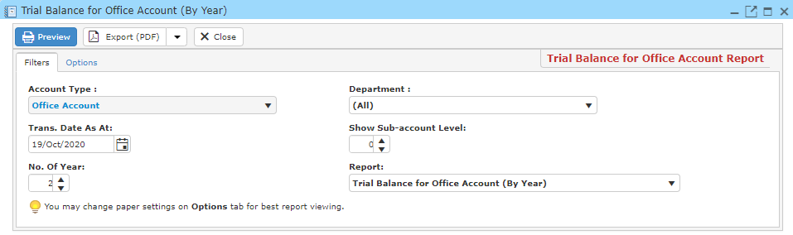

* Fill in your search criteria.
* If you wish to add watermark to your report, Click ‘**Options**’ and fill in the necessary information.

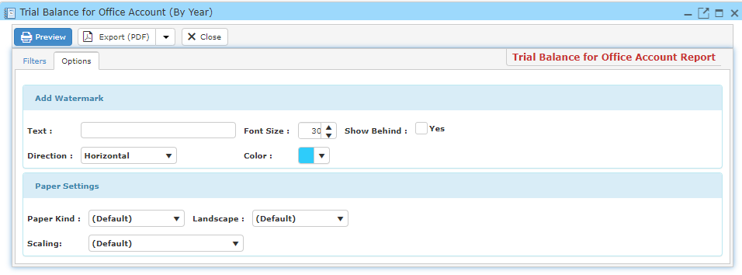

* Click ‘**Preview**’ to view and print out the Trial Balance for Office Account (By Year) report.
* You may also export this report in PDF or Excel format by clicking the ‘**Export**’ button.

**12.3 Account Reports – Payment Voucher**

**12.3.1 A/P Payment List Report**

This enables you to view and print A/P Payment List report.

* On the ‘**Report**’ Menu, click ‘**Account Reports – Payment Voucher'**.
* Click ‘A/P Payment List Report’ and a window will pop-up as the picture below.

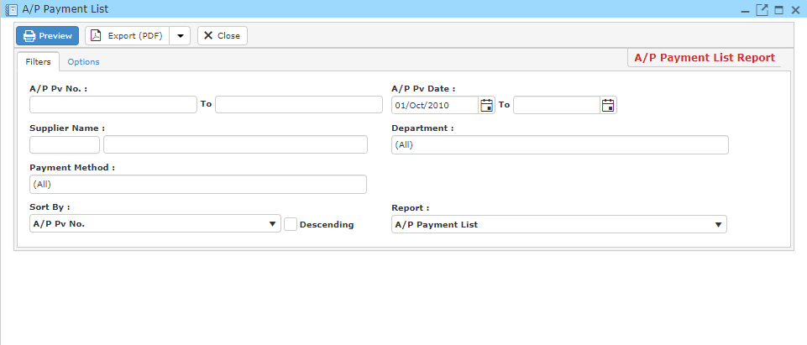

* Fill in your search criteria.
* If you wish to add watermark to your report, Click ‘**Options**’ and fill in the necessary information.

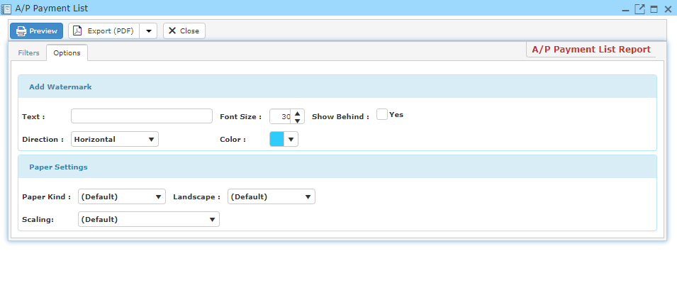

* Click ‘**Preview**’ to view and print out the A/P Payment List report.
* You may also export this report in PDF or Excel format by clicking the ‘**Export**’ button.

**12.3.2 Client’s A/C Payment Voucher List**

This enables you to view and print Clients’ A/C Payment Voucher List report.

* On the ‘**Report**’ Menu, click ‘**Account Reports – Payment Voucher**’.
* Click ‘**Client’s A/C Payment Voucher List**’ and a window will pop-up as the picture below.

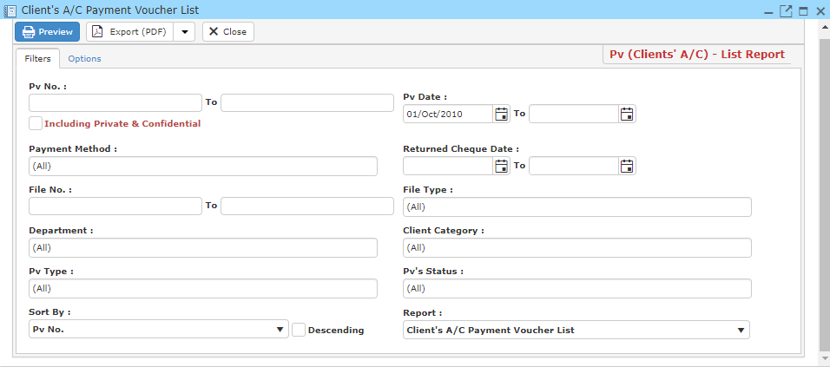

* Fill in your search criteria.
* If you wish to add watermark to your report, Click ‘**Options**’ and fill in the necessary information.

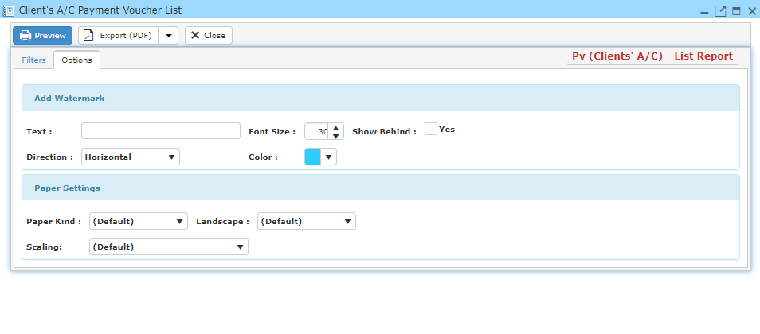

* Click ‘**Preview**’ to view and print out the Clients’ A/C Payment Voucher List report.
* You may also export this report in PDF or Excel format by clicking the ‘**Export**’ button.

**12.3.3 Office A/C Payment Voucher List**

This enables you to view and print Office A/C Payment Voucher List report.

* On the ‘**Report**’ Menu, click ‘**Account Reports – Payment Voucher**’.
* Click ‘Office A/C Payment Voucher List’ and a window will pop-up as the picture below.

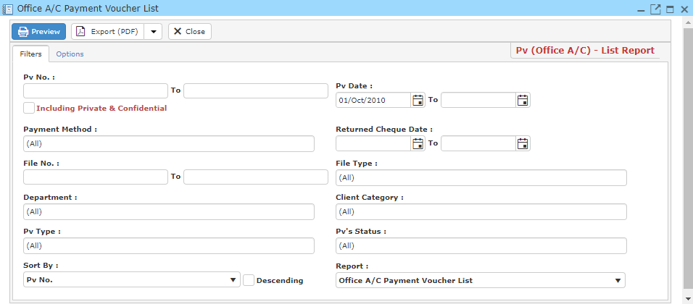

* Fill in your search criteria.
* If you wish to add watermark to your report, Click ‘**Options**’ and fill in the necessary information.

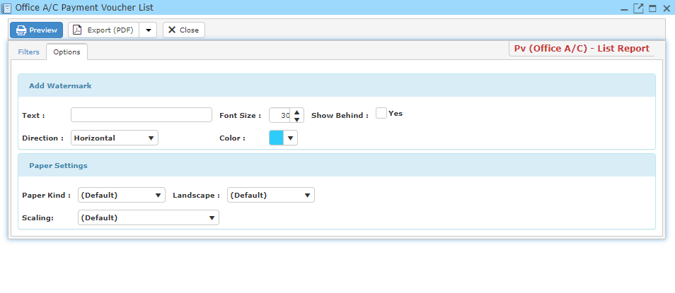

* Click ‘**Preview**’ to view and print out the Office A/C Payment Voucher List report.
* You may also export this report in PDF or Excel format by clicking the ‘**Export**’ button.

**12.4 Account Reports – Receipt / AR Receipt**

**12.4.1 A/R Receipt List**

This enables you to view and print A/R Receipt List report.

* On the ‘**Report**’ Menu, click ‘**Account Reports – Receipt / AR Receipt**’.
* Click ‘**A/R Receipt List**’ and a window will pop-up as the picture below.

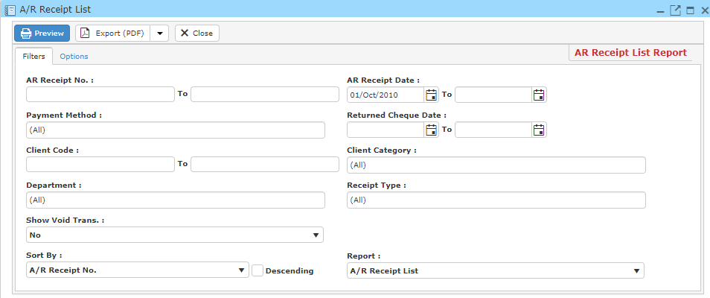

* Fill in your search criteria.
* If you wish to add watermark to your report, Click ‘**Options**’ and fill in the necessary information.

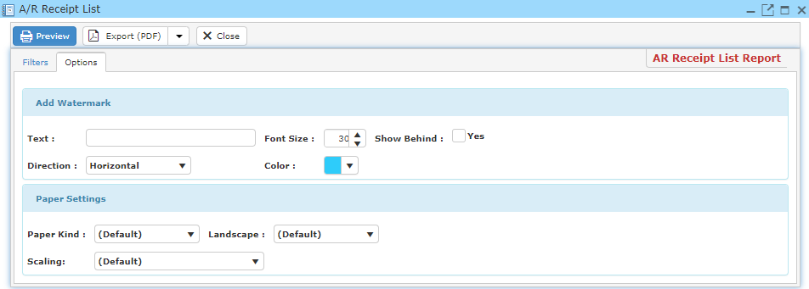

* Click ‘**Preview**’ to view and print out the A/R Receipt List report.
* You may also export this report in PDF or Excel format by clicking the ‘**Export**’ button.

**12.4.2 Contra Bill List**

This enables you to view and print Contra Bill List report.

* On the ‘**Report**’ Menu, click ‘**Account Reports – Receipt / AR Receipt**’.
* Click ‘**Contra Bill List**’ and a window will pop-up as the picture below.

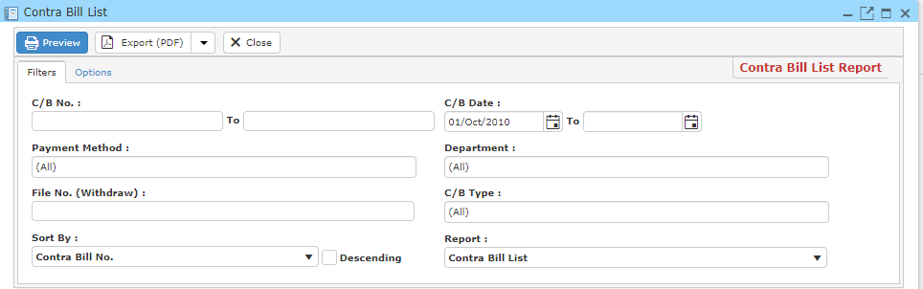

* Fill in your search criteria.
* If you wish to add watermark to your report, Click ‘**Options**’ and fill in the necessary information.

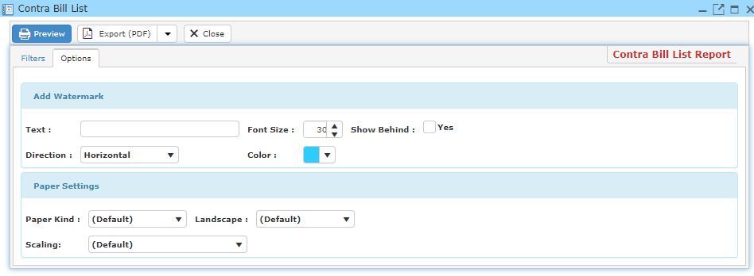

* Click ‘**Preview**’ to view and print out the Contra Bill List report.
* You may also export this report in PDF or Excel format by clicking the ‘**Export**’ button.

**12.4.3 Receipt List Report**

This enables you to view and print Receipt List report.

* On the ‘**Report**’ Menu, click ‘**Account Reports – Receipt / AR Receipt**’.
* Click ‘**Receipt List**’ and a window will pop-up as the picture below.

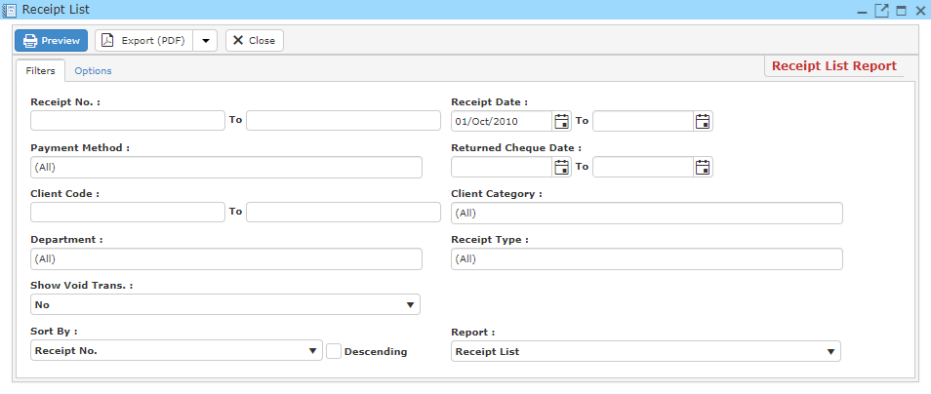

* Fill in your search criteria.
* If you wish to add watermark to your report, Click ‘**Options**’ and fill in the necessary information.

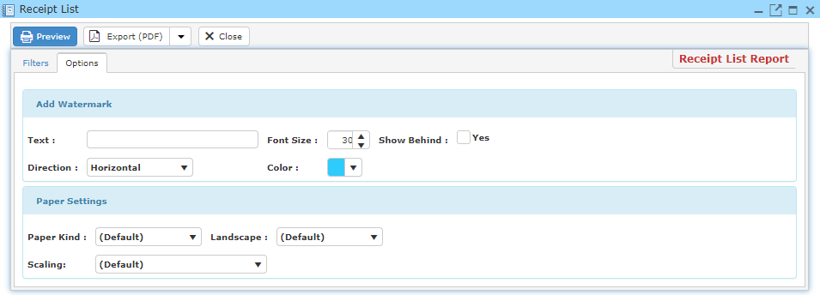

* Click ‘**Preview**’ to view and print out the Receipt List report.
* You may also export this report in PDF or Excel format by clicking the ‘**Export**’ button.

**12.4.4 Activity (A/R Trans)**

This enables you to view and print Activity (A/R Trans) report.

* On the ‘**Report**’ Menu, click ‘**Account Reports – Receipt / AR Receipt**’.
* Click ‘**Activity (A/R Trans)**’ and a window will pop-up as the picture below.

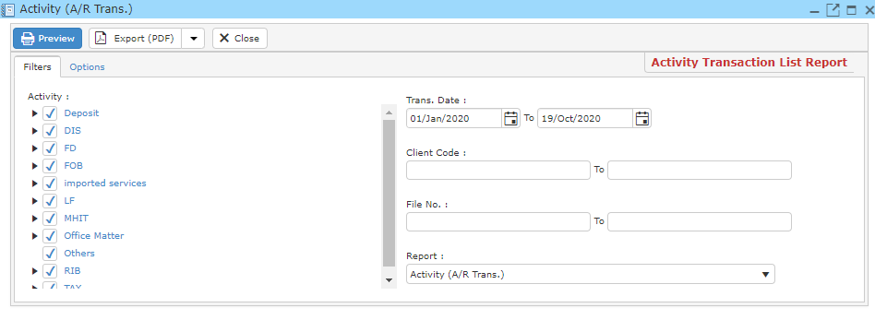

* Fill in your search criteria.
* If you wish to add watermark to your report, Click ‘**Options**’ and fill in the necessary information.

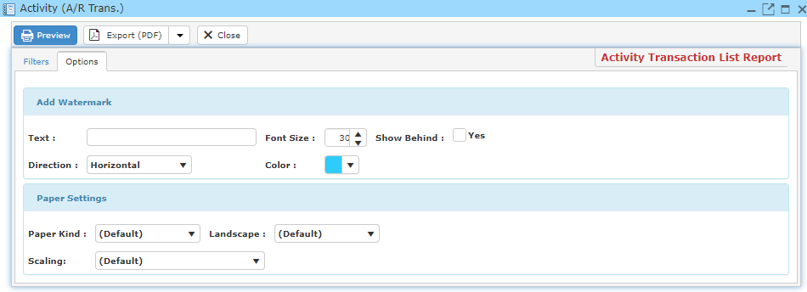

* Click ‘**Preview**’ to view and print out the Activity (A/R Trans) report.
* You may also export this report in PDF or Excel format by clicking the ‘**Export**’ button.

**12.5 Account Reports – Sales / Quotation**

**12.5.1 A/R CN List**

This enables you to view and print A/R CN List report.

* On the ‘**Report**’ Menu, click ‘**Account Reports – Sales / Quotation**’.
* Click ‘**A/R CN List**’ and a window will pop-up as the picture below.

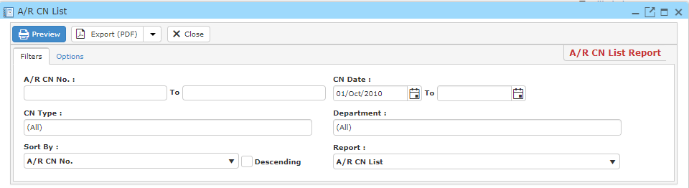

* Fill in your search criteria.
* If you wish to add watermark to your report, Click ‘**Options**’ and fill in the necessary information.

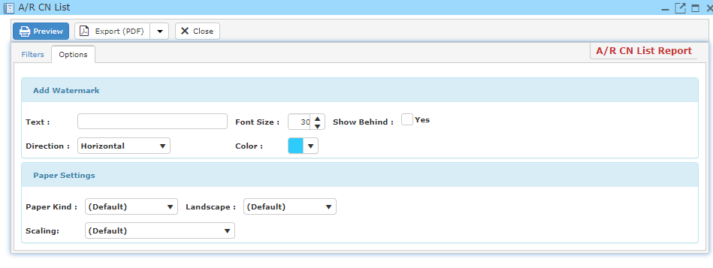

* Click ‘**Preview**’ to view and print out the A/R CN List report.
* You may also export this report in PDF or Excel format by clicking the ‘**Export**’ button.

**12.5.2 A/R DN List**

This enables you to view and print A/R DN List report.

* On the ‘**Report**’ Menu, click ‘**Account Reports – Sales / Quotation**’.
* Click ‘**A/R DN List**’ and a window will pop-up as the picture below.

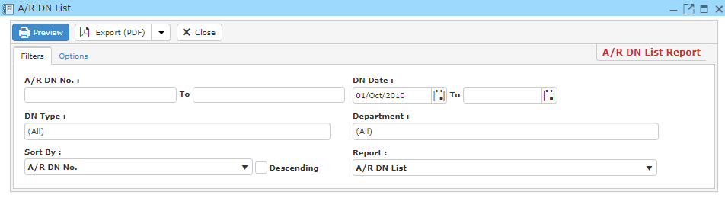

* Fill in your search criteria.
* If you wish to add watermark to your report, Click ‘**Options**’ and fill in the necessary information.

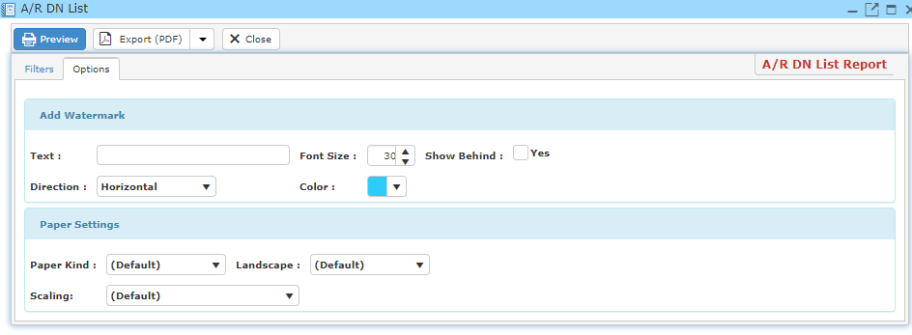

* Click ‘**Preview**’ to view and print out the A/R DN List report.
* You may also export this report in PDF or Excel format by clicking the ‘**Export**’ button.

**12.5.3 Account Statement**

This enables you to view and print Account Statement report.

* On the ‘**Report**’ Menu, click ‘**Account Reports – Sales / Quotation**’.
* Click ‘**Account Statement**’ and a window will pop-up as the picture below.

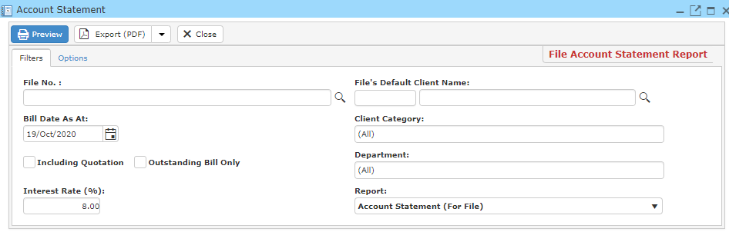

* Fill in your search criteria.
* If you wish to add watermark to your report, Click ‘**Options**’ and fill in the necessary information.

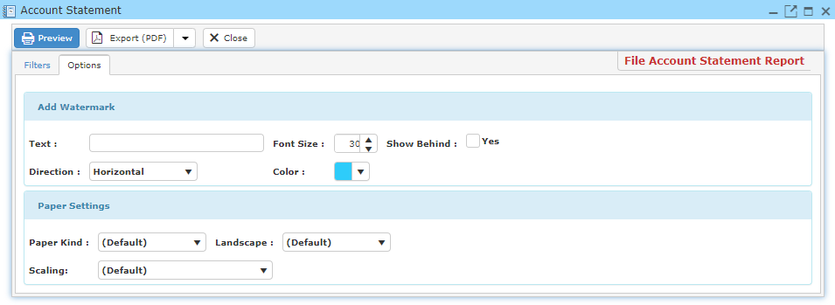

* Click ‘**Preview**’ to view and print out the Account Statement report.
* You may also export this report in PDF or Excel format by clicking the ‘**Export**’ button.

**12.5.4 Bill Listing**

This enables you to view and print Bill Listing report.

* On the ‘**Report**’ Menu, click ‘**Account Reports – Sales / Quotation**’.
* Click ‘**Bill Listing**’ and a window will pop-up as the picture below.

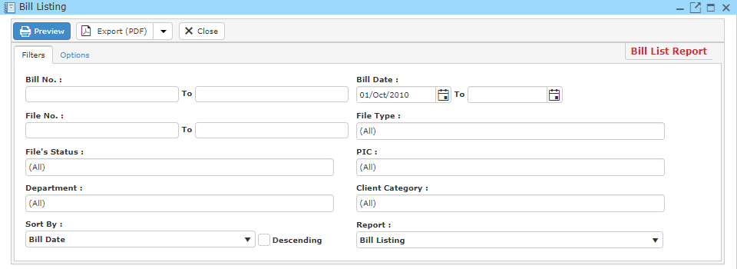

* Fill in your search criteria.
* If you wish to add watermark to your report, Click ‘**Options**’ and fill in the necessary information.

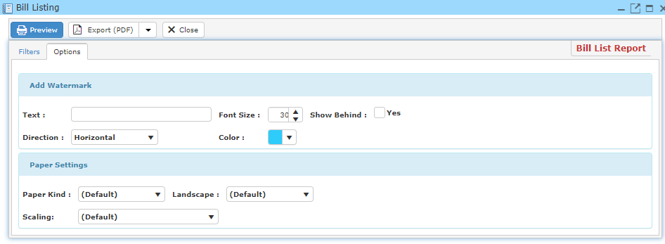

* Click ‘**Preview**’ to view and print out the Bill Listing report.
* You may also export this report in PDF or Excel format by clicking the ‘**Export**’ button.

**12.5.5 Bill Payment**

This enables you to view and print Bill Payment report.

* On the ‘**Report**’ Menu, click ‘**Account Reports – Sales / Quotation**’.
* Click ‘**Bill Payment**’ and a window will pop-up as the picture below.

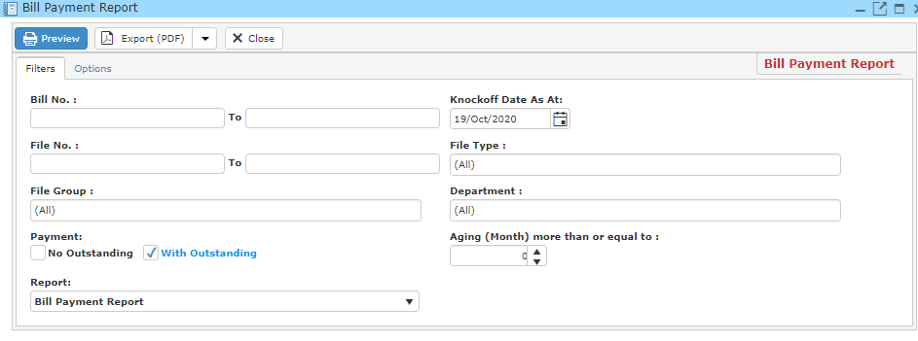

* Fill in your search criteria.
* If you wish to add watermark to your report, Click ‘**Options**’ and fill in the necessary information.

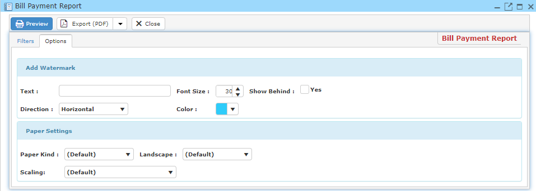

* Click ‘**Preview**’ to view and print out the Bill Payment report.
* You may also export this report in PDF or Excel format by clicking the ‘**Export**’ button.

**12.5.6 Time Cost Listing**

This enables you to view and print Time Cost Listing report.

* On the ‘**Report**’ Menu, click ‘**Account Reports – Sales / Quotation**’.
* Click ‘**Time Cost Listing**’ and a window will pop-up as the picture below.

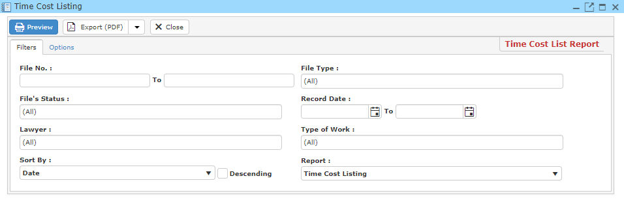

* Fill in your search criteria.
* If you wish to add watermark to your report, Click ‘**Options**’ and fill in the necessary information.

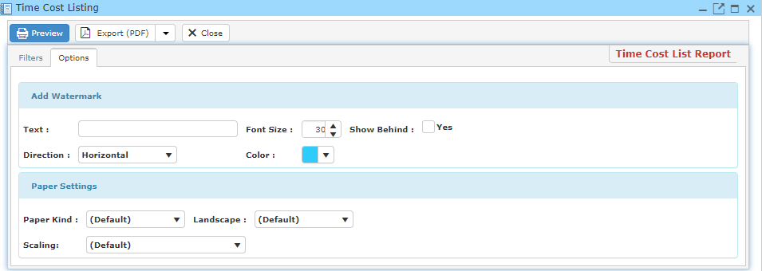

* Click ‘**Preview**’ to view and print out the Time Cost Listing report.
* You may also export this report in PDF or Excel format by clicking the ‘**Export**’ button.

**12.5.7 Past Bill List**

This enables you to view and print Past Bill List report.

* On the ‘**Report**’ Menu, click ‘**Account Reports – Sales / Quotation**’.
* Click ‘**Past Bill List**’ and a window will pop-up as the picture below.

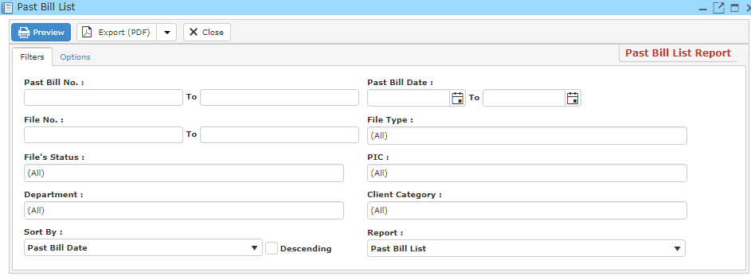

* Fill in your search criteria.
* If you wish to add watermark to your report, Click ‘**Options**’ and fill in the necessary information.

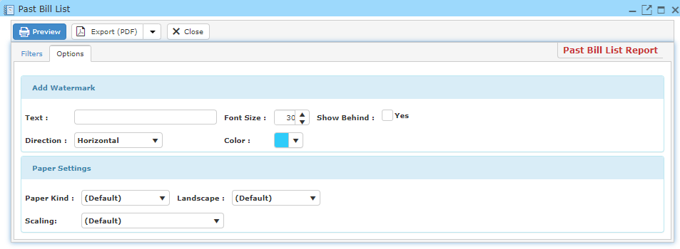

* Click ‘**Preview**’ to view and print out the Past Bill List report.
* You may also export this report in PDF or Excel format by clicking the ‘**Export**’ button.

**12.5.8 Quotation Listing**

This enables you to view and print Quotation Listing report.

* On the ‘**Report**’ Menu, click ‘**Account Reports – Sales / Quotation**’.
* Click ‘**Quotation Listing**’ and a window will pop-up as the picture below.

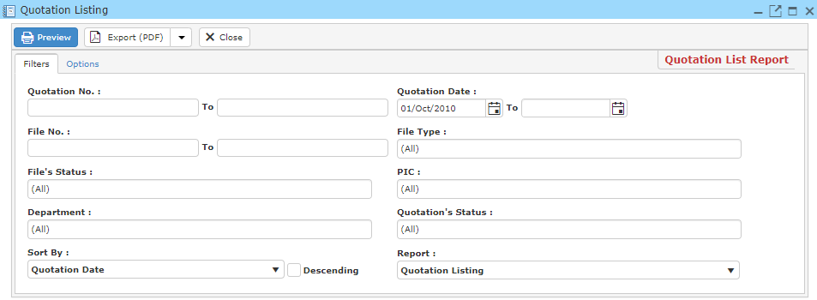

* Fill in your search criteria.
* If you wish to add watermark to your report, Click ‘**Options**’ and fill in the necessary information.

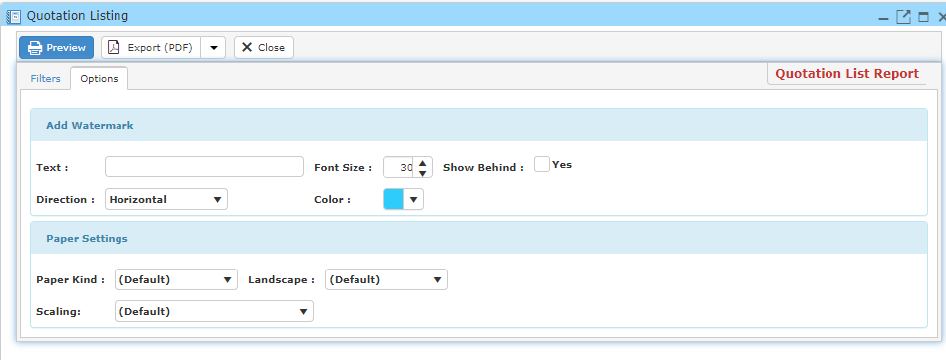

* Click ‘**Preview**’ to view and print out the Quotation Listing report.
* You may also export this report in PDF or Excel format by clicking the ‘**Export**’ button.

**12.6 Account Reports – Supplier**

**12.6.1 A/P CN List**

This enables you to view and print A/P CN List report.

* On the ‘**Report**’ Menu, click ‘**Account Reports – Supplier**’.
* Click ‘**A/P CN List**’ and a window will pop-up as the picture below.

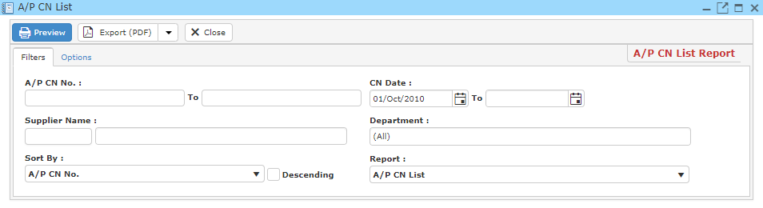

* Fill in your search criteria.
* If you wish to add watermark to your report, Click ‘**Options**’ and fill in the necessary information.

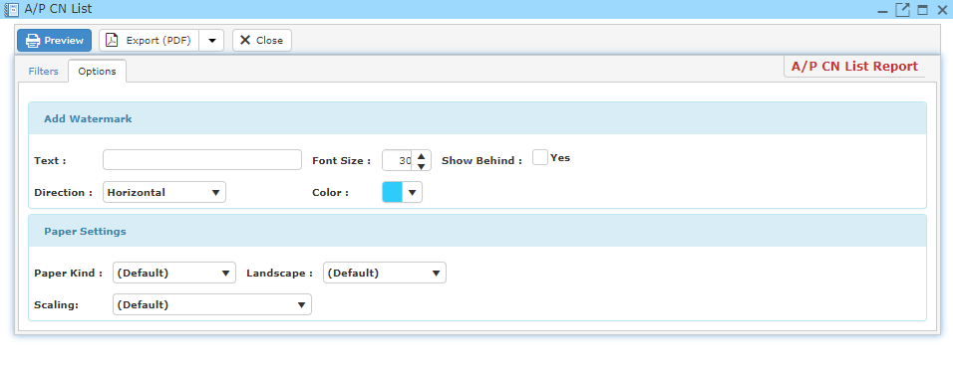

* Click ‘**Preview**’ to view and print out the A/P CN List report.
* You may also export this report in PDF or Excel format by clicking the ‘**Export**’ button.

**12.6.2 A/P DN List**

This enables you to view and print A/P DN List report.

* On the ‘**Report**’ Menu, click ‘**Account Reports – Supplier**’.
* Click ‘**A/P DN List**’ and a window will pop-up as the picture below.

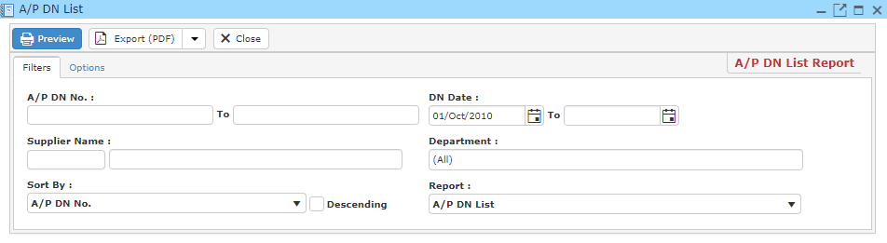

* Fill in your search criteria.
* If you wish to add watermark to your report, Click ‘**Options**’ and fill in the necessary information.

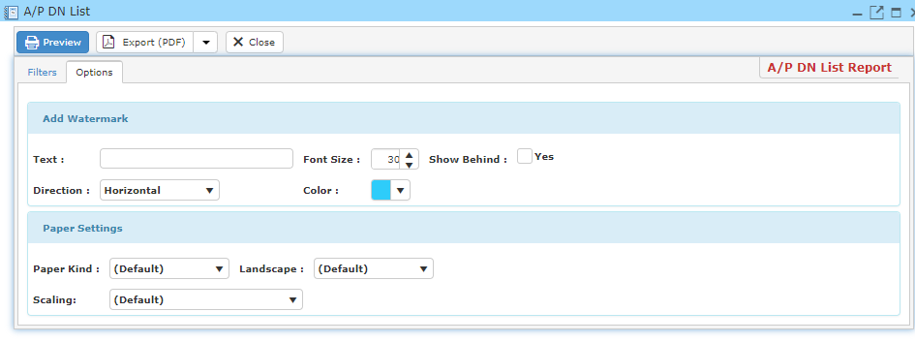

* Click ‘**Preview**’ to view and print out the A/P DN List report.
* You may also export this report in PDF or Excel format by clicking the ‘**Export**’ button.

**12.6.3 Invoice Aging Report**

This enables you to view and print Invoice Aging Report.

* On the ‘**Report**’ Menu, click ‘**Account Reports – Supplier**’.
* Click ‘**Invoice Aging Report**’ and a window will pop-up as the picture below.

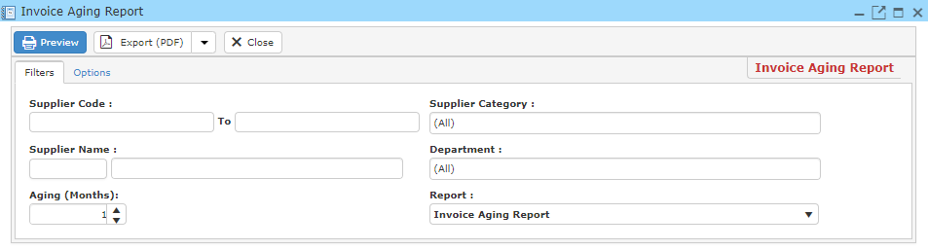

* Fill in your search criteria.
* If you wish to add watermark to your report, Click ‘**Options**’ and fill in the necessary information.

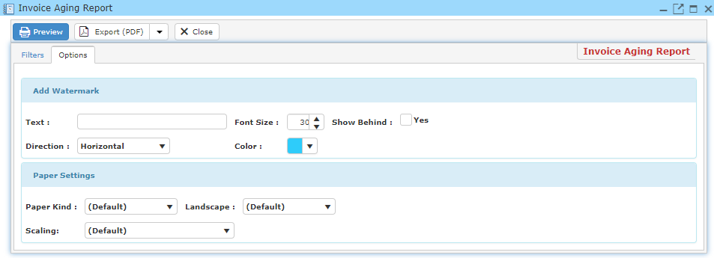

* Click ‘**Preview**’ to view and print out the Invoice Aging Report.
* You may also export this report in PDF or Excel format by clicking the ‘**Export**’ button.

**12.6.4 Supplier Invoice List**

This enables you to view and print Supplier Invoice List report.

* On the ‘**Report**’ Menu, click ‘**Account Reports – Supplier**’.
* Click ‘**Supplier Invoice List**’ and a window will pop-up as the picture below.

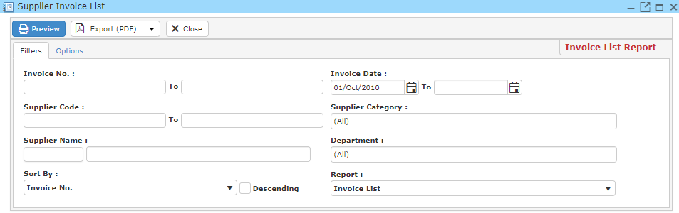

* Fill in your search criteria.
* If you wish to add watermark to your report, Click ‘**Options**’ and fill in the necessary information.

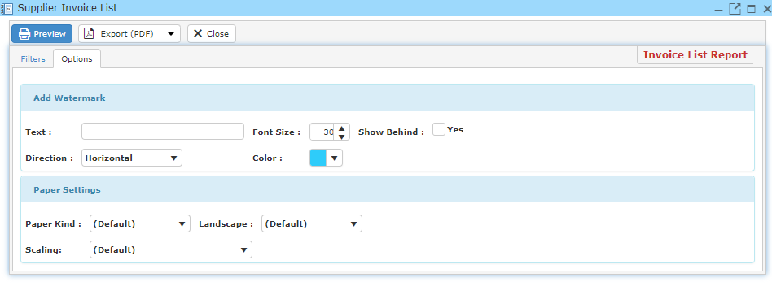

* Click ‘**Preview**’ to view and print out the Supplier Invoice List report.
* You may also export this report in PDF or Excel format by clicking the ‘**Export**’ button.

**12.6.5 Supplier Listing**

This enables you to view and print Supplier Listing report.

* On the ‘**Report**’ Menu, click ‘**Account Reports – Supplier**’.
* Click ‘**Supplier Listing**’ and a window will pop-up as the picture below.

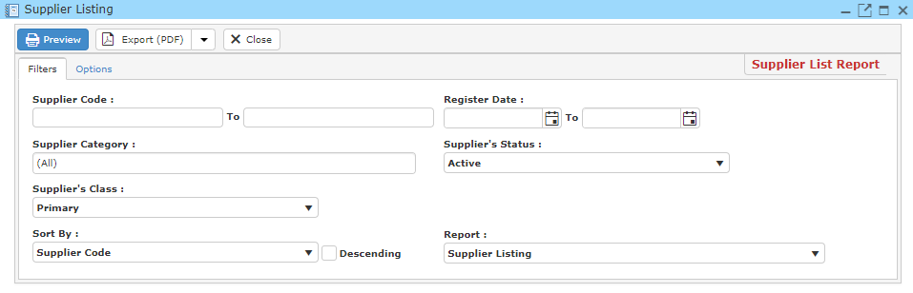

* Fill in your search criteria.
* If you wish to add watermark to your report, Click ‘**Options**’ and fill in the necessary information.

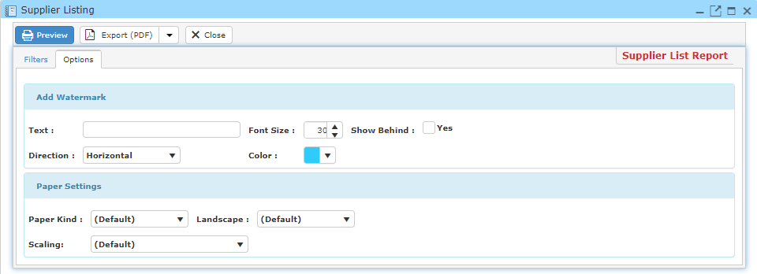

* Click ‘**Preview**’ to view and print out the Supplier Listing report.
* You may also export this report in PDF or Excel format by clicking the ‘**Export**’ button.

**12.7 Account Reports – Tax**

**12.7.1 GST Form 03**

This enables you to view and print GST Form 03 report.

* On the ‘**Report**’ Menu, click ‘**Account Reports – Tax**’.
* Click ‘**GST Form 03**’ and a window will pop-up as the picture below.
* Fill in your search criteria.
* If you wish to add watermark to your report, Click ‘**Options**’ and fill in the necessary information.
* Click ‘**Preview**’ to view and print out the GST Form 03 report.
* You may also export this report in PDF or Excel format by clicking the ‘**Export**’ button.

**12.7.2 GST Transaction List**

This enables you to view and print GST Transaction List report.

* On the ‘**Report**’ Menu, click ‘**Account Reports – Tax**’.
* Click ‘**GST Transaction List**’ and a window will pop-up as the picture below.

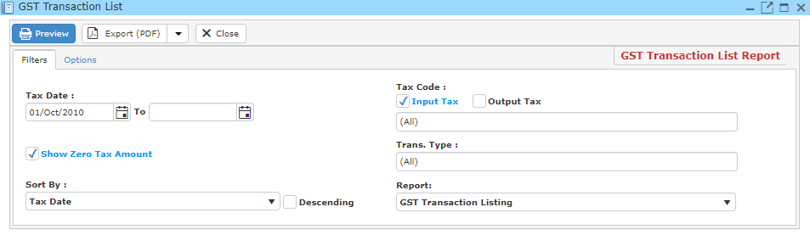

* Fill in your search criteria.
* If you wish to add watermark to your report, Click ‘**Options**’ and fill in the necessary information.

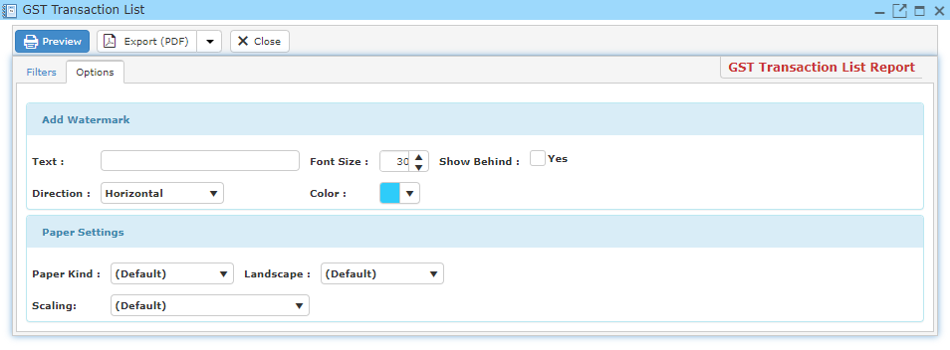

* Click ‘**Preview**’ to view and print out the GST Transaction List report.
* You may also export this report in PDF or Excel format by clicking the ‘**Export**’ button.

**12.7.3 SST 02 Form**

This enables you to view and print SST 02 Form report.

* On the ‘**Report**’ Menu, click ‘**Account Reports – Tax**’.
* Click ‘**SST 02 Form**’ and a window will pop-up as the picture below.
* Fill in your search criteria.
* If you wish to add watermark to your report, Click ‘**Options**’ and fill in the necessary information.
* Click ‘**Preview**’ to view and print out the SST 02 Form report.
* You may also export this report in PDF or Excel format by clicking the ‘**Export**’ button.

**12.7.4 SST Transaction List**

This enables you to view and print SST Transaction List report.

* On the ‘**Report**’ Menu, click ‘**Account Reports – Tax**’.
* Click ‘**SST Transaction List**’ and a window will pop-up as the picture below.

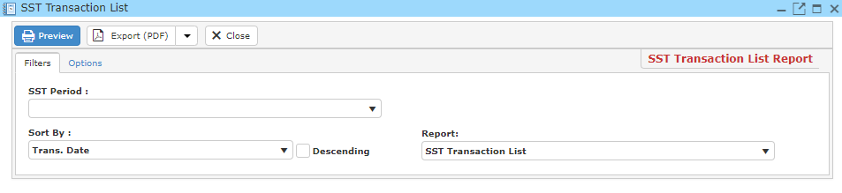

* Fill in your search criteria.
* If you wish to add watermark to your report, Click ‘**Options**’ and fill in the necessary information.

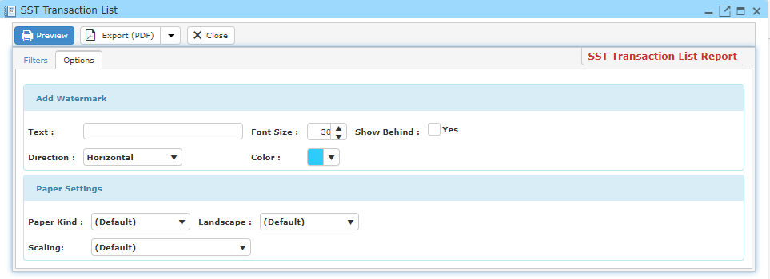

* Click ‘**Preview**’ to view and print out the SST Transaction List report.
* You may also export this report in PDF or Excel format by clicking the ‘**Export**’ button.

**12.8 General Reports**

**12.8.1 Activity Listing**

This enables you to view and print Activity Listing report.

* On the ‘**Report**’ Menu, click ‘**General Reports**’.
* Click ‘**Activity Listing**’ and a window will pop-up as the picture below.

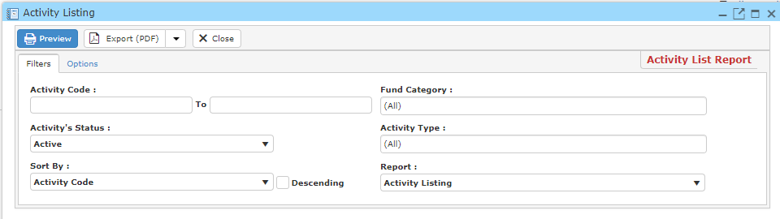

* Fill in your search criteria.
* If you wish to add watermark to your report, Click ‘**Options**’ and fill in the necessary information.

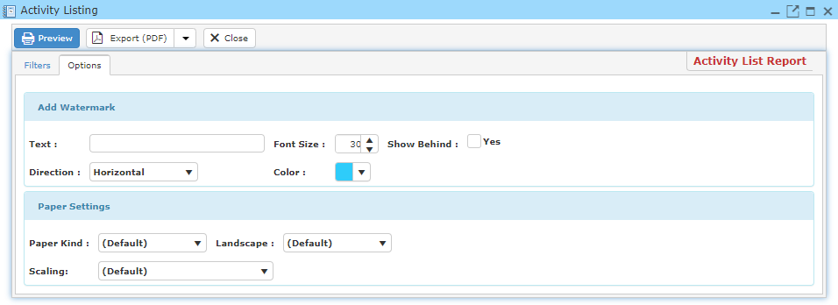

* Click ‘**Preview**’ to view and print out the Activity Listing report.
* You may also export this report in PDF or Excel format by clicking the ‘**Export**’ button.

**12.8.2 Client Listing**

This enables you to view and print Client Listing report.

* On the ‘**Report**’ Menu, click ‘**General Reports**’.
* Click ‘**Client Listing**’ and a window will pop-up as the picture below.

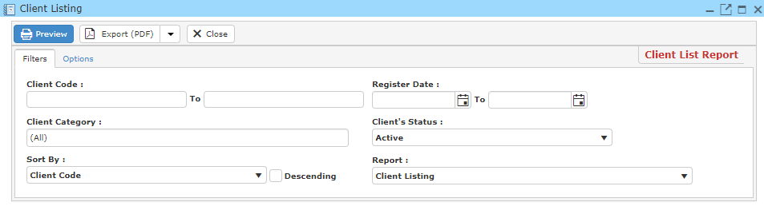

* Fill in your search criteria.
* If you wish to add watermark to your report, Click ‘**Options**’ and fill in the necessary information.

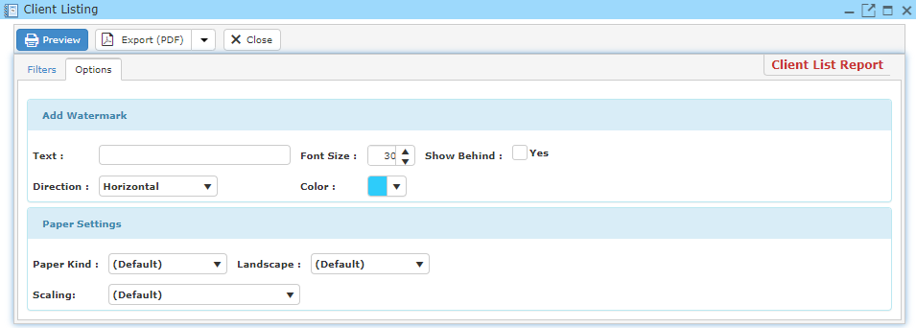

* Click ‘**Preview**’ to view and print out the ClientListing report.
* You may also export this report in PDF or Excel format by clicking the ‘**Export**’ button.

**12.8.3 Client Mailing Label**

This enables you to view and print Client Mailing Label report.

* On the ‘**Report**’ Menu, click ‘**General Reports**’.
* Click ‘**Client Mailing Label**’ and a window will pop-up as the picture below.

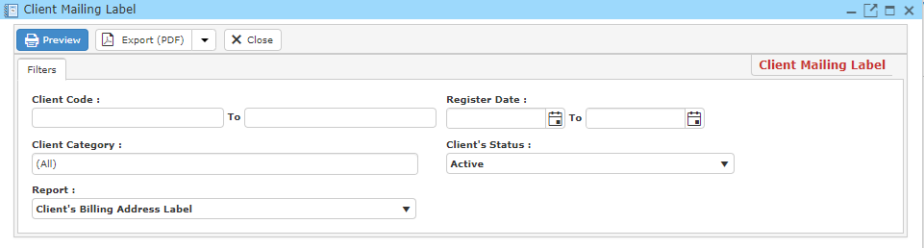

* Click ‘**Preview**’ to view and print out the Client Mailing Label report.
* You may also export this report in PDF or Excel format by clicking the ‘**Export**’ button.

**12.8.4 File Detail SpreadSheet**

This enables you to view and print File Detail SpreadSheet report.

* On the ‘**Report**’ Menu, click ‘**General Reports**’.
* Click ‘**File Detail SpreadSheet**’ and a window will pop-up as the picture below.
* Fill in your search criteria.
* If you wish to add watermark to your report, Click ‘**Options**’ and fill in the necessary information.
* Click ‘**Preview**’ to view and print out the File Detail SpreadSheet report.
* You may also export this report in PDF or Excel format by clicking the ‘**Export**’ button.

**12.8.5 File Listing**

This enables you to view and print File Listing report.

* On the ‘**Report**’ Menu, click ‘**General Reports**’.
* Click ‘**File Listing**’ and a window will pop-up as the picture below.

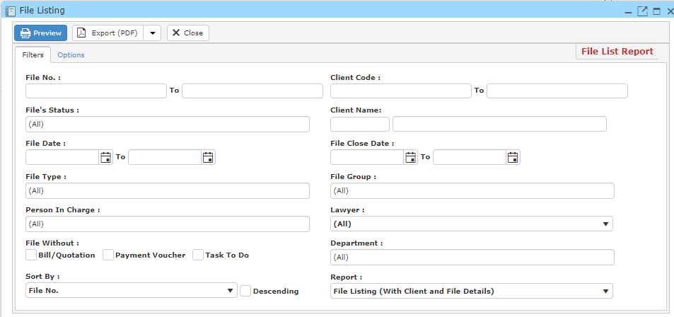

* Fill in your search criteria.
* If you wish to add watermark to your report, Click ‘**Options**’ and fill in the necessary information.

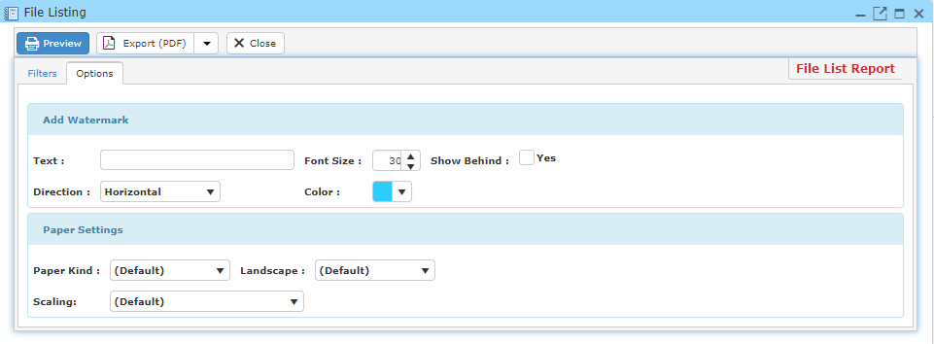

* Click ‘**Preview**’ to view and print out the File Listing report.
* You may also export this report in PDF or Excel format by clicking the ‘**Export**’ button.

**12.8.6 File Summary**

This enables you to view and print File Summary report.

* On the ‘**Report**’ Menu, click ‘**General Reports**’.
* Click ‘**File Summary**’ and a window will pop-up as the picture below.
* Fill in your search criteria.
* If you wish to add watermark to your report, Click ‘**Options**’ and fill in the necessary information.
* Click ‘**Preview**’ to view and print out the File Summary report.
* You may also export this report in PDF or Excel format by clicking the ‘**Export**’ button.

**12.9 Task/Workflow Report**

**12.9.1 Appointment List**

This enables you to view and print appointment record listing.

* On the ‘**Report**’ Menu, click ‘**Task/Workflow Reports**’.
* Click ‘**Appointment List**’ and a window will pop-up as the picture below.

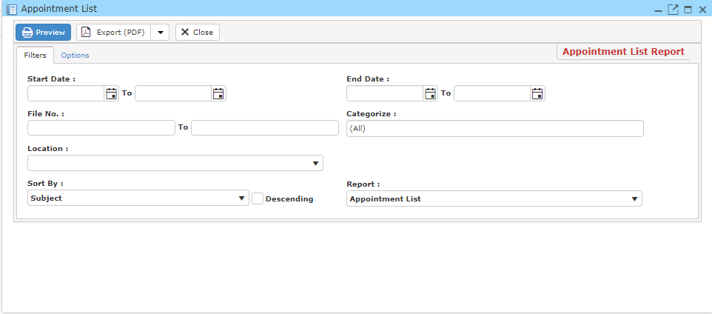

* Fill in your search criteria.
* If you wish to add watermark to your report, Click ‘**Options**’ and fill in the necessary information.

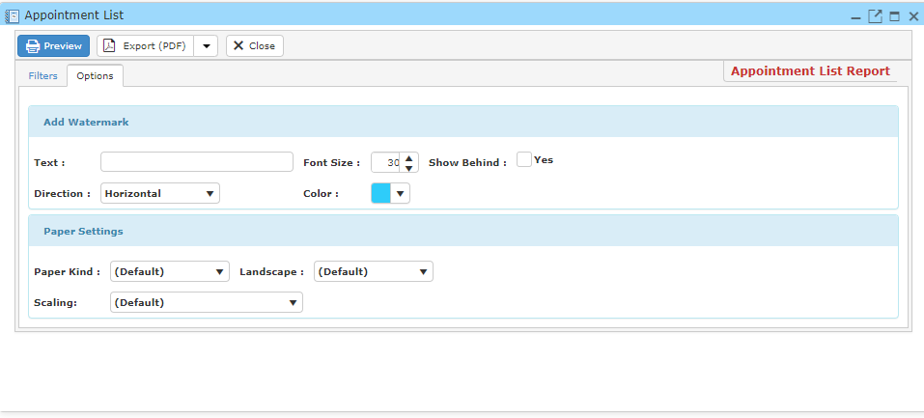

* Click ‘**Preview**’ to view and print out the Appointment List report.
* You may also export this report in PDF or Excel format by clicking the ‘**Export**’ button.

**12.9.2 Court Matter List**

This enables you to view and print Court Matter record listing.

* On the ‘**Report**’ Menu, click ‘**Task/Workflow Reports**’.
* Click ‘**Court Matter List**’ and a window will pop-up as the picture below.

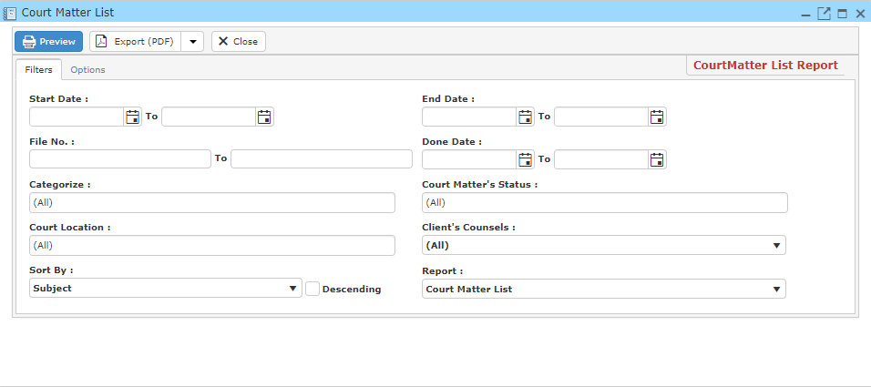

* Fill in your search criteria.
* If you wish to add watermark to your report, Click ‘**Options**’ and fill in the necessary information.

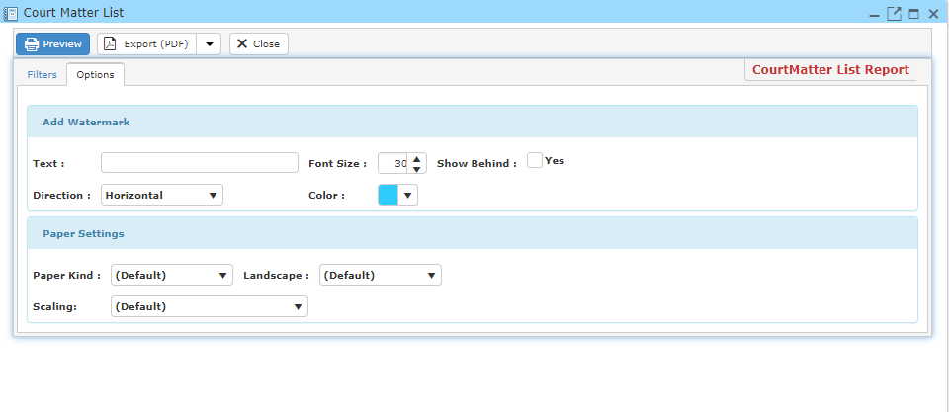

* Click ‘**Preview**’ to view and print out the court matter report.
* You may also export this report in PDF or Excel format by clicking the ‘**Export**’ button.

**12.9.3 Task To Do List**

This enables you to view and print task to do record listing.

* On the ‘**Report**’ Menu, click ‘**Task/Workflow Reports**’.
* Click ‘**Appointment List**’ and a window will pop-up as the picture below.

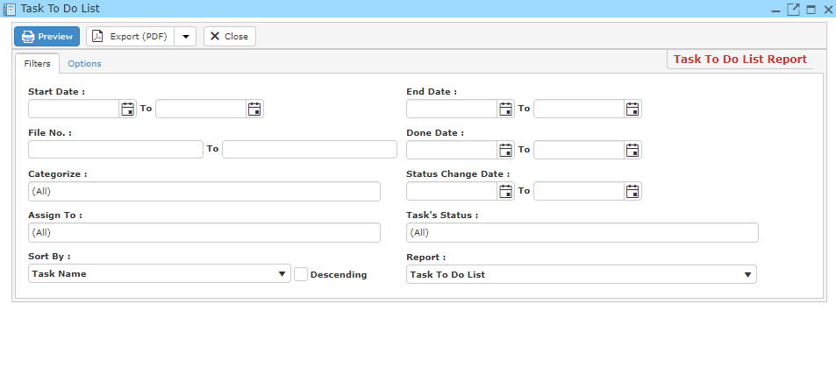

* Fill in your search criteria.
* If you wish to add watermark to your report, Click ‘**Options**’ and fill in the necessary information.

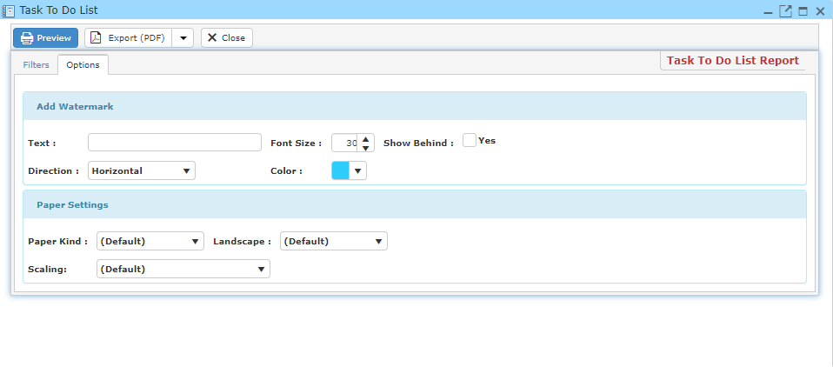

* Click ‘**Preview**’ to view and print out the task to do list report.
* You may also export this report in PDF or Excel format by clicking the ‘**Export**’ button.

**12.10 Manage Report**

This option enables you to manage report.

* On the ‘**Report**’ Menu, click ‘**Manage Report**’.
* A window will pop-up as the picture below.

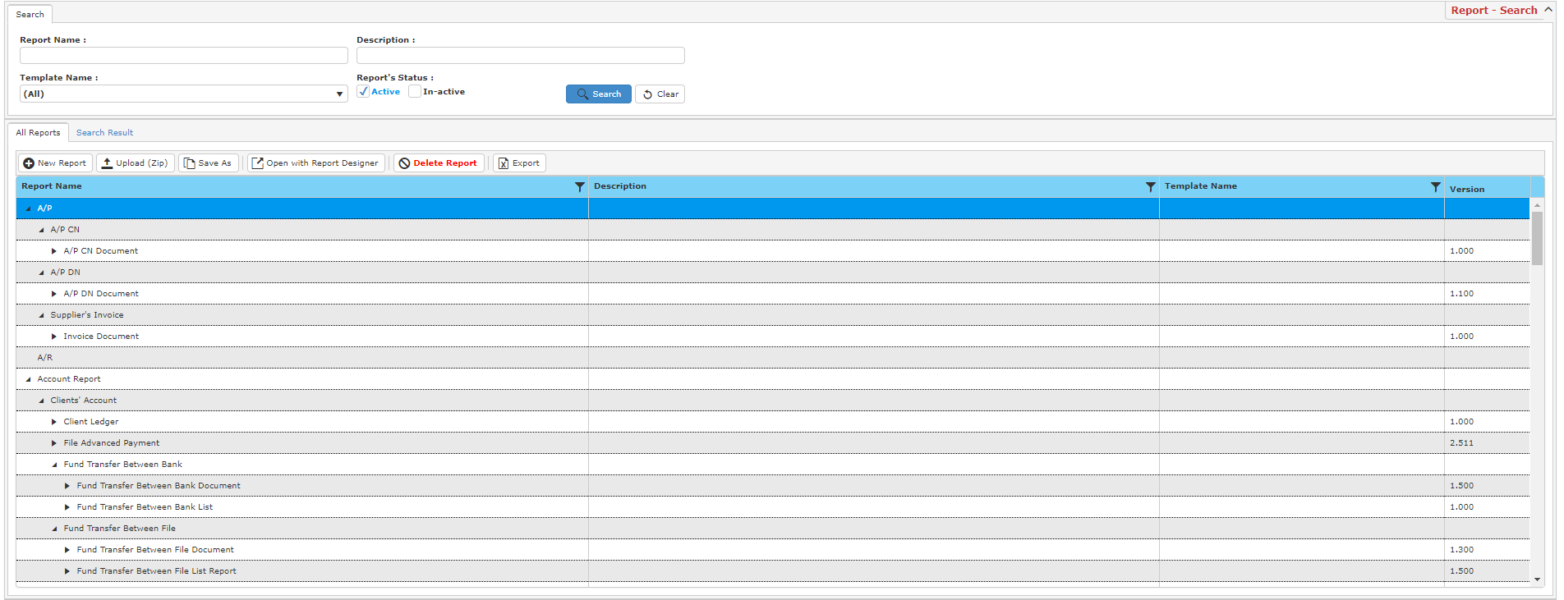

**Search Report**

* To search for a report, type in your search criteria and click **Search** and a result list will be displayed as below.

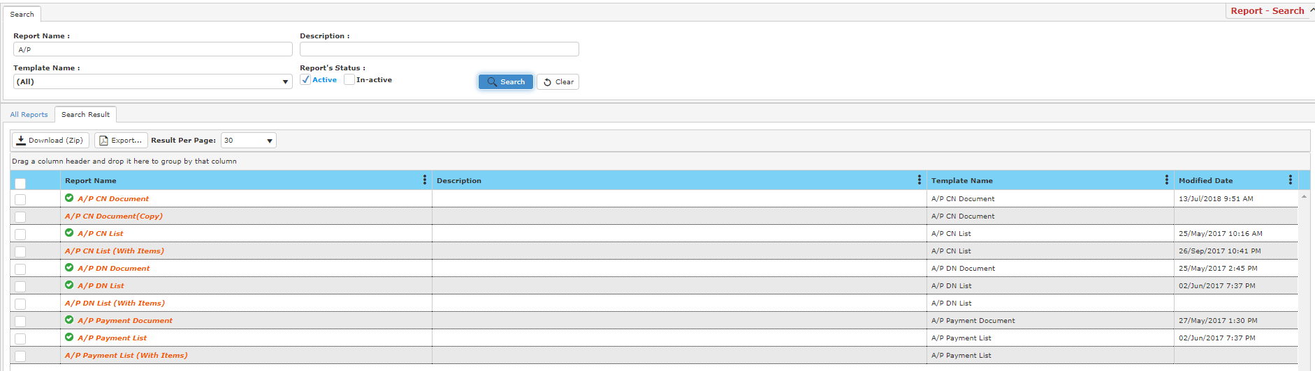

**Creating New Report**

* To create a new report, click **New Report** in **All Report** tab.

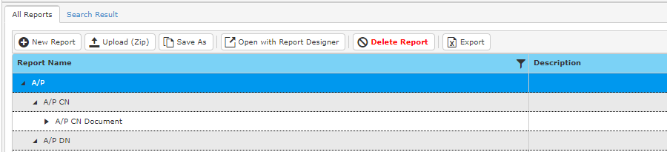

* A new window will be displayed.

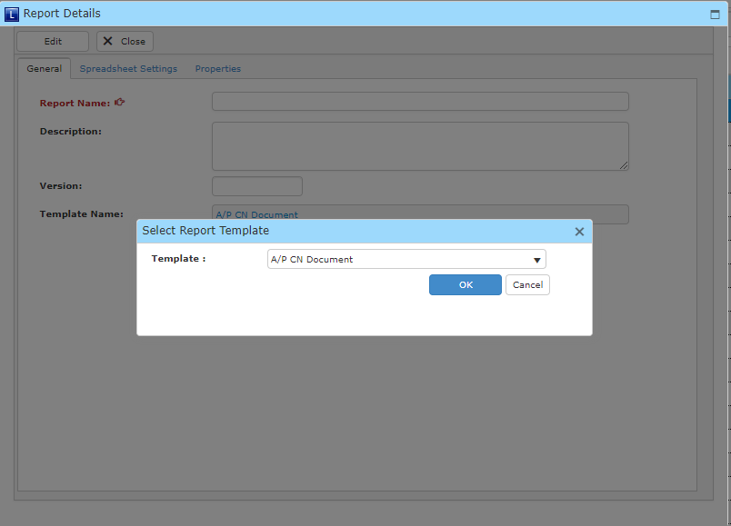

* To begin, choose a template type.

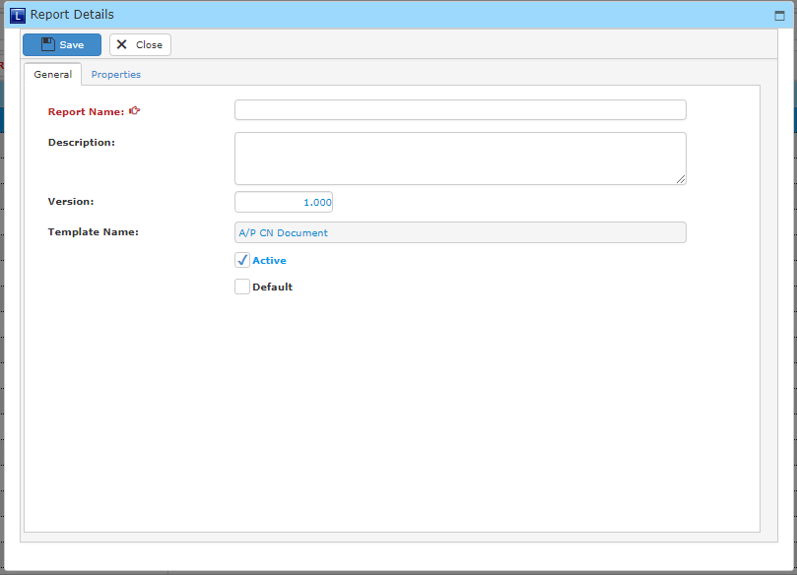

* Fill in the fields below and click **Save** once you have completed.

**Upload Report**

* To upload a report, click **Upload (ZIP)** in **All Reports** tab and a new window will be displayed as below.

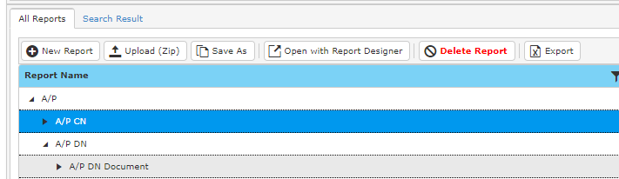

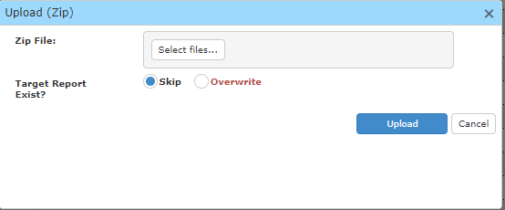

* Click **Select Files** to choose a file from your computer.
* **You** may choose skip if you wish to keep the existing report and the to-be-uploaded report.
* Click **Upload** to upload the report.